What will we be learning?  Section A: Performance and Response (04) Written Examination – 1 hour and 30 minutes  This is Section A of your written paper which is worth 50 of the 80 marks.  Study of the set play ‘Blood Brothers’ by Willy Russell  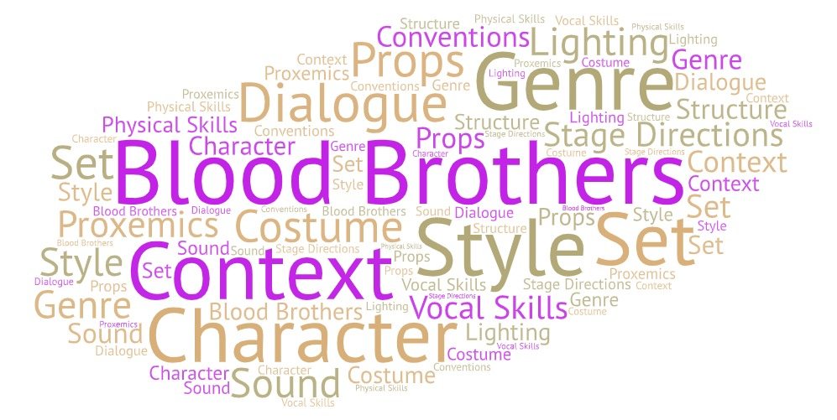 | Why this? Why now?  Year 10  You will practically and theoretically study the set play in preparation for your written examination which will take place in year 11.  Future Learning –  A Level Drama and Theatre Studies  Sweeney Todd by Christopher Bond  Frankenstein by Nick Dear  Othello by William Shakespeare  Key Words:  Social Context  Historical Context  Cultural Context  Genre  Structure  Characters  Form  Styles  Plot  Dialogue  Stage directions  Set  Props  Costume  Lighting  Sound  Conventions
What will we learn?
AO3 - Demonstrate knowledge and understanding of how drama and theatre is developed and performed.
- The contexts of the text – social, historical (time set, and period written) and cultural.
- The theatrical conventions of the period in which the text was created.
- The genre of the play.
- The structure of the play.
- The characters.
- The form and style.
- The theatrical setting.
- The plot and subplot.
- The dialogue.
- The stage directions.
- How meaning is created through the use of performance space and spatial awareness on the stage.
- The relationships between the performer and the audience.
- The design of the: set, props, costume, lighting and sound.
- An actors vocal and physical interpretation of the character.

What opportunities are there for wider study?
LAMDA Performance Exams – individual and group tuition at school.
Senior Drama Club (Year 8, 9, 10 and 11) – to perform in projects such as ‘National Theatre Connections Plays’
Theatre Trips – Visit a local theatre or head to the West End in London to see a live performance.
Visit the National Theatre Live website to stream a live theatre performance
Further revision resources:
https://www.bbc.co.uk/bitesize/examspecs/zbpwd6f
Specification and past papers:
https://www.ocr.org.uk/qualifications/gcse/drama-j316-from-2016/
How will I be assessed?
You will be assessed through the written examination which will take place in year 11. The written component is worth 30% of your GCSE.
This is Section A of your written paper which is worth 50 of the 80 marks. This section is made up of 4 mark, 6 mark and 8 mark questions.

Year 11 Mock Exam and June External Exam Example Questions
- Explain how the following line has an impact on this character in the performance text you have studied.
Mrs Johnstone “With one more baby we could have managed. But not with two.”
- Explain how, as a director you would show the social, historical and/or cultural context in the following scene. You may discuss the direction and/or the design of your chosen performance text
Blood Brothers
Mickey and Edward’s meeting
- Choose a theme and explain how as a Director you would highlight it within the stage production of ‘Blood Brothers’

- As a sound designer, how would you use sound to add atmosphere to this montage? Justify your answer.

- Discuss how a director could stage the opening of the performance text you have studied to engage the audience from the start. You may refer to the direction of the performers and/or design of the scene in your answer.

